Introduction to Assignment Rules: Group Assignment Solution

Exercise 1: Investigation

1. Log on to ClaimCenter as Andy Applegate and navigate to one of Andy’s claims. Reassign the claim using "Use automated assignment". Step through the code.
   1. Did the Global Claim rules execute? Yes
   2. Did the Default Group rules execute? Yes
2. Repeat the process, but this time, explicitly reassign the claim to the **Auto1 - TeamB** group. Step through the code.
   1. Did the Global Claim rules execute? No
   2. Did the Default Group rules execute? Yes

5. Repeat the process, but this time, explicitly reassign the claim to Chris Craft in the Auto1 - TeamA group. Step through the code.

* 1. Did the Global Claim rules execute? No
  2. Did the Default Group rules execute? No

**Exercise 2: Configuration**

Configure ClaimCenter to meet the following customer requirement from Acme Insurance.

1. This lab depends upon the users and groups created in the "Users and Groups" lab.

Requirement 1: Assigning Complex Theft Claims to Complex Thefts - West

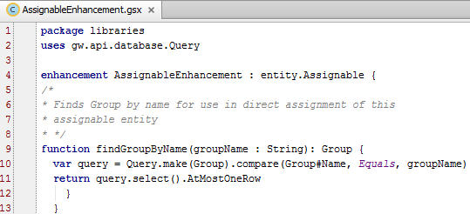

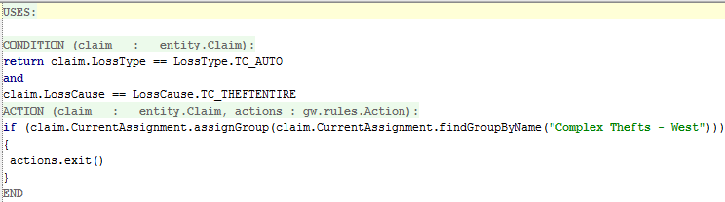

Requirement 2: Assigning Complex Theft Claims Based on Region

